

Salesforce Commerce Cloud LINK Cartridge Controller Test Cases

Salesforce Commerce Cloud LINK Cartridge Integration Guide

Shopping Cart Abandonment Integration Guide

Contents

Component Overview 3

Shopping Cart Abandonment 3

Activity Tracking 3

Scheduled Jobs 3

Newsletter Subscription 3

Modal Acquisition 3

Click / Conversion Tracking 3

Test Cases: Cartridge Enabled 4

Test 1: JavaScript Loaded 4

Test 2: Order Confirmation Code 4

Test 3: Product Browse Activity Code 5

Test 4: Newsletter Subscription/Email Capture 5

Test 5: SCA/Cart Activity Code 6

Note on Scheduled Jobs 6

Note on Testing Modals and Click/Conversion Tracking 6

Test Cases: Cartridge Disabled 7

Test 1: JavaScript Not Loaded 7

Test 2: Order Confirmation Code Disabled 7

Test 3: Product Browse Activity Code Disabled 7

Test 4: Newsletter Subscription/Email Capture Disabled 7

Test 5: SCA/Cart Activity Code Disabled 8

Note on Disabling Scheduled Jobs 8

Note on Disabling Modals and Click/Conversion Tracking 8

# Component Overview

### Shopping Cart Abandonment

As shoppers add items to their cart, a session is created and tracked by the Listrak cartridge. If the customer does not complete a purchase before leaving the site, the session will be marked as an abandoned cart. If an email address was attached to the shopping cart, Listrak will trigger a cart abandonment email series.

### Activity Tracking

As shoppers browse your store and look at products, the Listrak cartridge will log this activity and store it for marketing campaigns. JavaScript generated on your site by the cartridge will capture events to send to a Listrak endpoint so that no information is stored within your SFCC instance.

### Scheduled Jobs

Data is sent to Listrak on a continuous basis by scheduled jobs. Order history is exported regularly and sent to Listrak. Customer and product information is exported to file and uploaded to Listrak daily using the SFCC FTP client.

### Newsletter Subscription

The Listrak cartridge enables merchants to push data to Listrak as customers complete forms to subscribe to a newsletter. These form elements are configured as custom objects through the BM and added as hidden fields to any existing form.

### Modal Acquisition

Functionality is included to display a modal popup to request customers to sign up to an email marketing list. The popup configuration is controlled within the Listrak application but code is inserted into pages by the cartridge to ensure the popup can appear anywhere.

### Click / Conversion Tracking

When a visitor arrives at the storefront as a result of a click on an email sent from Listrak, a cookie is set for that session. If an order is completed within 30 days, the originating message is credited with the conversion revenue.

# Test Cases: Cartridge Enabled

### Test 1: JavaScript Loaded

**Pre-Requisites:** Cartridge Enabled

**Steps:**

* On any page, open the console in the browser’s development tools
* Enter **_ltk** into the console
* Look for a **_ltk** object in the console

**Expected Result:** The **_ltk** object exists, meaning the JavaScript was successfully loaded.

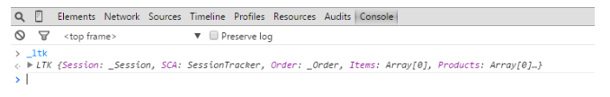

### Test 2: Order Confirmation Code

**Pre-Requisites:** Cartridge Enabled

**Steps:**

* Open the network tab in the browser’s development tools
* Apply a filter of **listrak**
* Place an order on the test site
* Look for a **T.ashx** call, with query string parameters matching the placed order

**Expected Result:** The **T.ashx** call exists, confirming the order was submitted to Listrak.

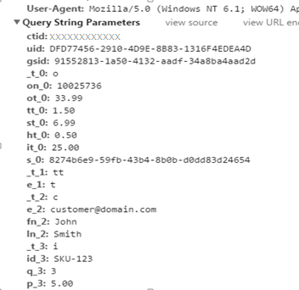

### Test 3: Product Browse Activity Code

**Pre-Requisites:** Cartridge Enabled

**Steps:**

* Open the network tab of the browser’s developer tools
* Apply a filter of **listrak**
* Navigate to any product page on the test site
* Look for a requestcontaining the MerchantID, an activity type of ProductBrowse and the SKU

**Expected Result:** The request contains ProductBrowse and the browsed product’s SKU, confirming the activity code was submitted to Listrak.

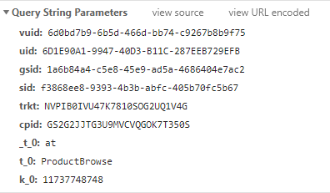

### Test 4: Newsletter Subscription/Email Capture

**Pre-Requisites:** Cartridge Enabled, cartridge settings configured; add form input name/id into custom cartridge preferences under **Email Capture Fields**. Example **dwfrm_profile_customer_email** under account registration.

**Steps:**

* Open the network tab of the browser’s developer tools
* Navigate to any page with a newsletter input
* Enter an e-mail address in the text field, do not submit
* Click outside of the text box
* Look for a query string containing the email as a parameter

**Expected Result:** The query string exists, confirming the email capture code is working.

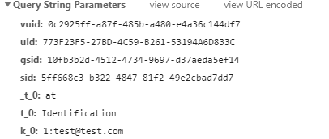

### Test 5: SCA/Cart Activity Code

**Pre-Requisites:** Cartridge Enabled

**Steps:**

* Open the network tab of the browser’s developer tools
* Apply a filter of **listrak**
* Add a product to the cart
* Look for an **update?gsid** request containing the item added to cart **Note: SFRA will file this call on the next page load. SG will produce this call a soon as an item is added to the cart from the produt page.**
* Add another product to the cart
* Look for a new **update?gsid** request containing both items in the cart
* Navigate to the cart page and remove an item from the cart, ensure cart to click update cart if applicable
* Look for another **update?gsid** request containing only the one item in the cart

**Expected Result:** Only one item remains in the cart, confirming cart activity is being captured.

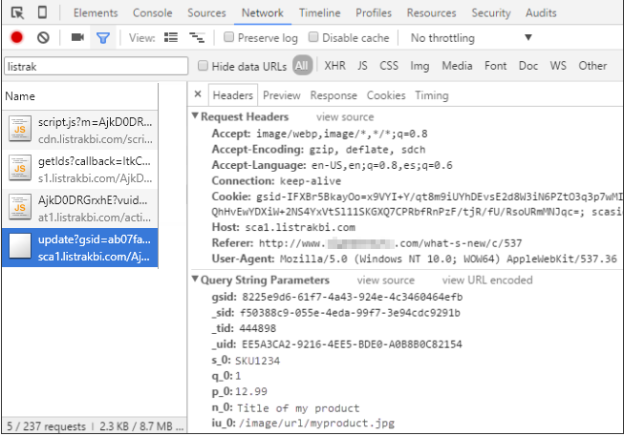

### Note on Scheduled Jobs

The Listrak Customer Sync, Order Sync and Product Sync scheduled jobs will run so long as the cartridge is enabled.

### Note on Testing Modals and Click/Conversion Tracking

Both features rely on the cartridge’s JavaScript to function. If the JavaScript loads, both will be working and do not need separate testing.

# Test Cases: Cartridge Disabled

### Test 1: JavaScript Not Loaded

**Pre-Requisites:** Cartridge Disabled

**Steps:**

* On any page, open the console in the browser’s development tools
* Enter **_ltk** into the console
* Look for a **_ltk** object in the console

**Expected Result:** The **_ltk** object does not exist, meaning the JavaScript was not loaded.

### Test 2: Order Confirmation Code Disabled

**Pre-Requisites:** Cartridge Disabled

**Steps:**

* Open the network tab in the browser’s development tools
* Apply a filter of **listrak**
* Place an order on the test site
* Look for a **T.ashx** call

**Expected Result:** The **T.ashx** call does not exist, confirming the order confirmation code is disabled.

### Test 3: Product Browse Activity Code Disabled

**Pre-Requisites:** Cartridge Disabled

**Steps:**

* Open the network tab of the browser’s developer tools
* Apply a filter of **listrak**
* Navigate to any product page on the test site
* Look for a requestcontaining the MerchantID, an activity type of ProductBrowse and the SKU

**Expected Result:** No such request exists, confirming the activity capture code is disabled.

### Test 4: Newsletter Subscription/Email Capture Disabled

**Pre-Requisites:** Cartridge Disabled

**Steps:**

* Open the network tab of the browser’s developer tools
* Navigate to any page with a newsletter input
* Enter an e-mail address in the text field, do not submit
* Click outside of the text box
* Look for a query string containing the email as a parameter

**Expected Result:** The query string does not exist, confirming the email capture code is disabled.

### Test 5: SCA/Cart Activity Code Disabled

**Pre-Requisites:** Cartridge Disabled

**Steps:**

* Open the network tab of the browser’s developer tools
* Apply a filter of **listrak**
* Add a product to the cart
* Check that no **update?gsid** request fires
* Add another product to the cart
* Check that no **update?gsid** request fires
* Navigate to the cart page and remove an item from the cart.
* Check that no **update?gsid** request fires

**Expected Result:** No **update?gsid** requests fire, confirming cart activity is disabled.

### Note on Disabling Scheduled Jobs

If the cartridge is disabled but the Listrak Customer Sync, Order Sync and Product Sync scheduled jobs are not, an error will be logged and the jobs will not run.

### Note on Disabling Modals and Click/Conversion Tracking

Both features rely entirely on the cartridge’s JavaScript to function. If the JavaScript does not load, both will be disabled and do not need separate testing.